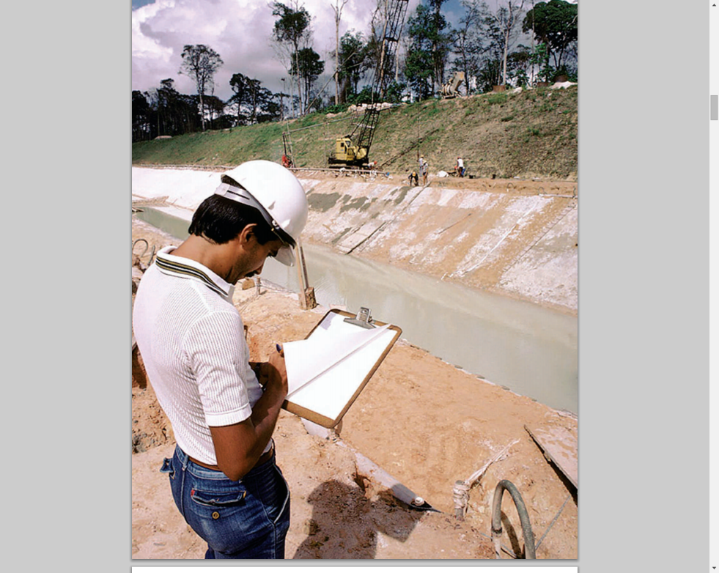

**CoST style guide for members**

***By CoST International Secretariat Communications***

***May 2019***

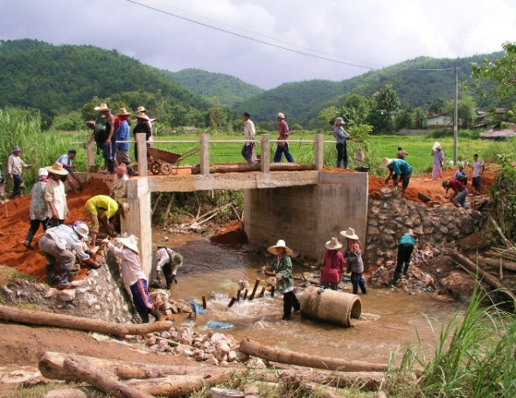

**Table of contents**

**1. About this guide** 3

**2. Email communication** 3

**3. Format for CoST documents** 3

**4. CoST colour palette** 4

**5. Guidelines for promotional materials** 5

Tone 5

Stock Imagery 5

CoST photographs 7

Consent 9

**6. CoST logo guidance** 10

CoST logo for member & affiliate member programmes 10

CoST IS logo guidance 10

Partner and funder logos 10

**7. CoST house style** 11

Specific CoST language 11

**Concluding remarks** 13

**Annex 1: CoST glossary of terms** 14

# **1. About this guide**

This guide is an adapted version of the CoST International Secretariat (CoST IS) Comms and Style Guide. It is intended for guidance only; whilst members are encouraged to use the standards applied within, in most instances these can be adapted to suit the needs of member programmes. Please direct any questions you may have to the CoST IS Communications Team.

# **2. Email communication**

Emails sent regarding CoST business should be sent from the email accounts set up by CoST IS for each CoST member which has the formation: [countryname@infrastructuretransparency.org](mailto:countryname@infrastructuretransparency.org).

These same emails can be used to access certain folders stored on the CoST IS shared drive.

Should you encounter difficulties in accessing the emails or shared documents please contact the CoST IS Office Administrator.

# 3. **Format for CoST documents**

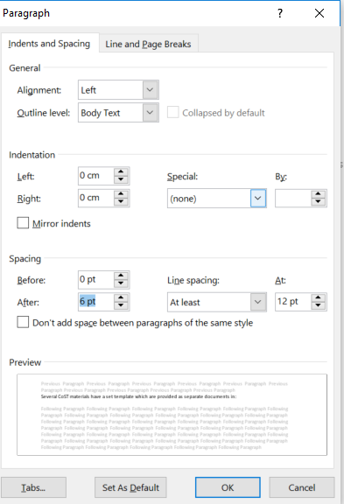The **official font** of CoST IS is Arial, size 11. It is justified in most cases. Paragraph spacing should be 0pt/6pt before and after paragraphs and ‘at least’ ‘12’ for ‘line spacing’.

Several CoST materials have a set template which are provided as separate documents in [CoST/Comms&Outreach/HouseStyle/AccompanyingMaterials](https://engineersagainstpoverty-my.sharepoint.com/personal/j_hawkins_engineersagainstpoverty_org/Documents/Data/3.10%20CosT/Comms%20%26%20Outreach/House%20style/CoST/Style%20guide%20accompanying%20materials), here, they can be copied and adapted for their purpose. If used this adaptation should include inserting the relevant CoST member logo in place of the CoST IS one. Permission to use the CoST IS logo should be requested to the CoST IS Communications Team.

Templates are provided for the following:

1. CoST word document (Use for example for terms of reference, concept notes, etc.)
2. Internal report template (Used for example for donor reports, guides, strategies, board paper etc.)
3. Letterhead
4. PowerPoint presentations
5. Press releases

# **4. CoST colour palette**

In 2018 we revised our colour palette. The following codes can be provided to designers or used in-house when creating materials. RGB colours are preferably used on **digital** **media** and CMYK colours are to be used for **print** communications.

# 

# **5. Guidelines for promotional materials**

## Tone

CoST language for promotional materials should be clear, concise and engaging. CoST takes a ‘middle-of-the-road’ approach in the tone of its written communication. Whilst the CoST IS aims to influence a technical audience, namely, the infrastructure governance community, the open government community and the construction industry, written communication should not be overly complicated and avoid overuse of technical wording and jargon.

These tonal messages are applicable to our audiences, and therefore should be adapted for CoST member audiences if used:

* **Knowledgeable/convincing:** The experts within CoST have the best available knowledge about transparency in infrastructure
* **Open/honest**: Fitting with the ethos of the initiative
* **Inspirational**: Emotive, yet with simple appeal
* **Context-sensitive**: Adapting to political contexts and remaining sensitive to local conditions
* **Achievable**: CoST delivers impact, seeing systemic change even in the most difficult of environments
* **Realistic/modest**: Willing to start small and have the CoST message spread.

## Stock Imagery

Following a review of our communications two years ago, CoST themes have withdrawn from a focus exclusively on the technical side of a ‘construction’ / ‘infrastructure’ identity and have balanced this with a **softer ‘infrastructure’ thematic** which demonstrates the **social impact** of CoST.

Images should not only be on the more traditional ideas of construction and infrastructure, such as roads, buildings and bridges but should, for example, include hospitals, schools, water infrastructure, farming, airports and ports. Imagery should also incorporate a mix demographics and infrastructure levels covering low, middle and high-income countries.

Example images below reflect this **style**, being available from [Google Advanced Image Search](https://www.google.com/advanced_image_search) with the usage rights filter ‘Free to use or share’.

Example images demonstrating social impact from different contexts

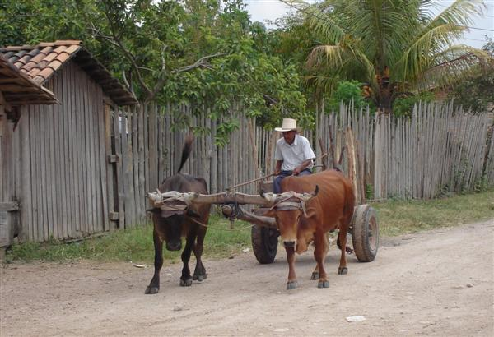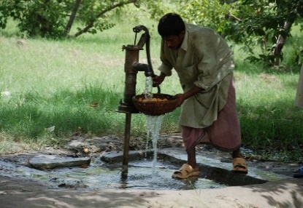

[](https://www.google.co.uk/url?sa=i&rct=j&q=&esrc=s&source=images&cd=&cad=rja&uact=8&ved=0CAcQjRxqFQoTCOOWgt_L9sgCFYjJFAodPYkEmw&url=https://en.wikipedia.org/wiki/London_King's_Cross_railway_station&bvm=bv.106379543,d.d24&psig=AFQjCNFLBvDjk2iq8z_bzyw0P9xK8HerZQ&ust=1446720416167391) [](https://pixabay.com/en/photos/wind%20turbines/)



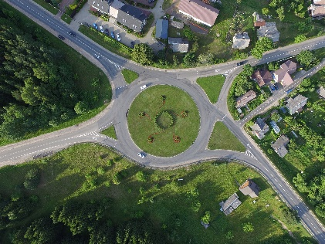

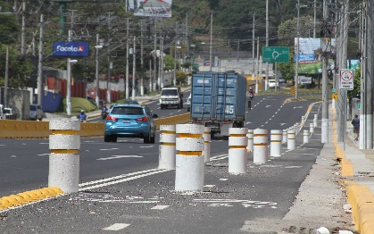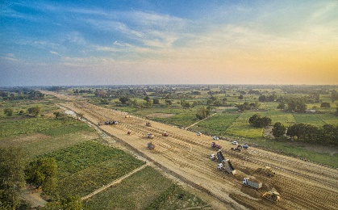

Example images of infrastructure / construction sites from different contexts

These images should try to adhere to the practices we promote, e.g. good health and safety on sites, hardhats and protective gloves worn.

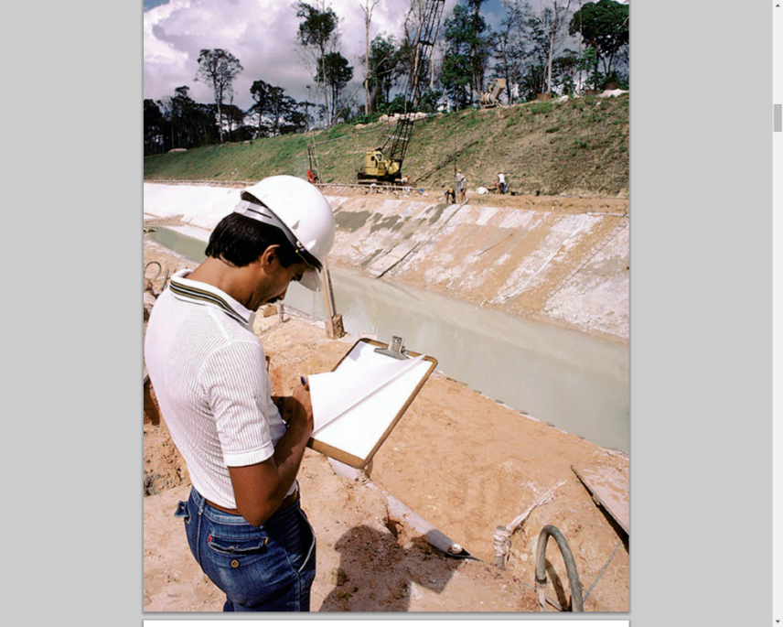 

When selecting images for use in CoST communications, the audience you are targeting should be the first consideration. Some general rules can be taken onboard, including whether they:

* Tell people that CoST values social impact in a traditionally technical sector
* Represent the equality, accountability and accessibility that CoST strives for
* Adhere to CoST communications principles.

All images should also respect copyright and reference laws where applicable. The following websites provide good resources for free image usage: [Google Advanced Image Search](https://www.google.com/advanced_image_search) (usage rights filter ‘Free to use or share’, as mentioned above); [Flickr](http://www.flickr.com/) (use the [Advanced Search Page](http://www.flickr.com/search/advanced), and search "Only search within Creative Commons-licensed content"); [Pixabay](https://pixabay.com/); [Picjumbo](https://picjumbo.com/); [morgueFile](http://www.morguefile.com/archive/#/?q=infrastructure); [Freeimages](http://www.freeimages.com/).

## CoST photographs

CoST image library

The CoST image library has been gradually evolving and includes a range of images from the past two years from our national programmes. These images are in: [CoST/Comms&Outreach/Photos](https://engineersagainstpoverty-my.sharepoint.com/personal/j_hawkins_engineersagainstpoverty_org/Documents/Data/3.10%20CosT/Comms%20%26%20Outreach/Photos).

We encourage members to copy over image to this folder and categorise them according to the theme and year. If you would like to use images within this folder, please contact CoST IS Communications.

CoST images

Where relevant, CoST IS uses its images to promote the initiative and to complement our stock imagery. Focus should be on the ‘CoST in action’ images such as those from our features of social accountability and assurance.

The images should be high-resolution and appropriate to the size they are cropped to. For example, images of groups of people only work on larger sizes whereas close up images of one-two people work better for smaller images.

Examples of CoST-specific photos

*CoST ‘in action’ images:*

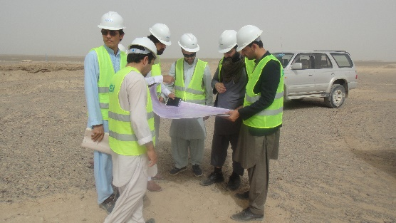 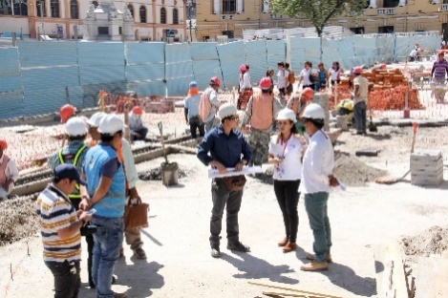

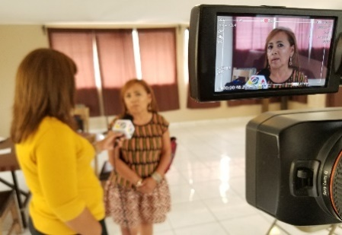 

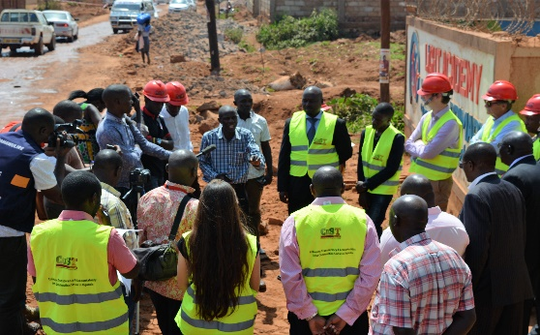

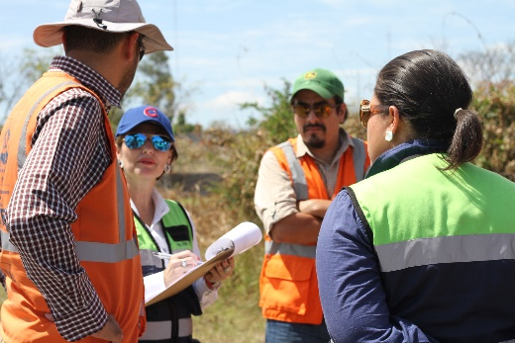

*Good examples of CoST images from events:*

* Ensure these are good quality, high resolution, make sure the photograph details (date and time) are not on the image!
* Go for interaction over group shots at workshops, group shots are overused and tend to mean more to the organisation than the audience!
* If you do use a group shot, make sure it is clear, the group is looking at the camera and it is interesting (e.g. taken from above or outside)
* If focussing on a panel, get one of the speaker engaging the audience – e.g. use of hand gestures to show their passion for the subject
* Add something different to the mix, for example, an interesting angle

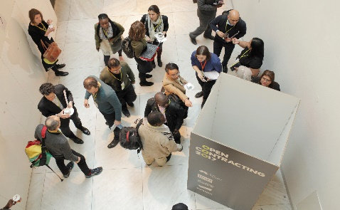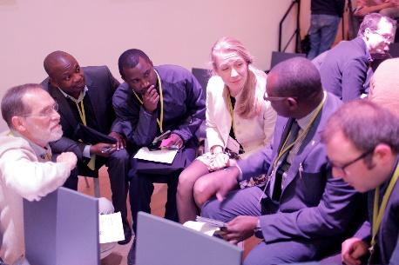

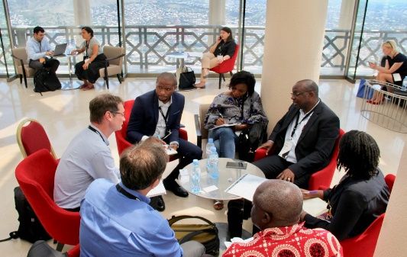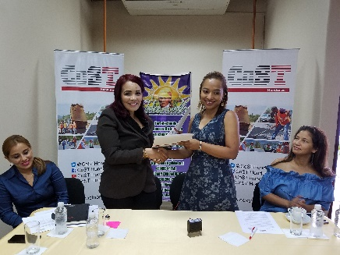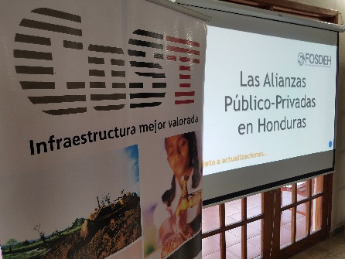



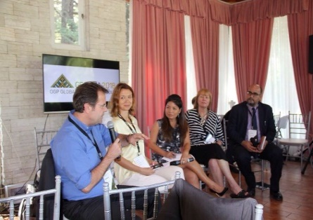

## Consent

Consent should also be obtained prior to photographs being taken of potential new CoST members.

In instances where the subject is a child, adolescent or beneficiary of CoST (e.g. a citizen affected by infrastructure in their community) a consent form should be signed and dated by the individual. The form should clearly outline what the photograph will be used for.

# **6. CoST logo guidance**

The logo is the **cornerstone** of the visual identity. It is the signature of the CoST initiative and the affiliation of all national programmes.

## CoST logo for member & affiliate member programmes

1. Member & Affiliate Secretariats each have their own version of the CoST logo.
2. The rights to use the CoST name and logo, including derivative versions, are withdrawn if a country’s CoST status is revoked by the CoST Board.

The various versions of the logos for national secretariats can be found in: [CoST/Comms&Outreach/CoSTLogo/CountryLogo](https://engineersagainstpoverty-my.sharepoint.com/personal/j_hawkins_engineersagainstpoverty_org/Documents/Data/3.10%20CosT/Comms%20%26%20Outreach/Logos/CoST%20logo/CoST%20country%20logos).

## CoST IS logo guidance

CoST IS guidance on the use of its logo by external bodies can be found on its website: [www.infrastructuretransparency.org/wp-content/uploads/2019/08/CoST-logo-guidance.pdf](http://www.infrastructuretransparency.org/wp-content/uploads/2019/08/CoST-logo-guidance.pdf).

## Partner and funder logos

CoST IS partners and funders each have their own logo guidance which should be followed. Logo and branding guidance is often available on an organisations’ website, if this can’t be found it can usually be obtained from the organisation’s communications department.

In most cases you will need to obtain permission from the *partner* to use their logo. Normally *funders* oblige the use their logo on certain materials, without necessarily having to check with the funder on its appropriate use so long as you adhere to their branding guidelines.

Below are the direct links for CoST’s two principal donors’ logo guidance.

DFID

1. [UK Aid Branding Guidance](https://assets.publishing.service.gov.uk/government/uploads/system/uploads/attachment_data/file/771876/UK-aid-branding-guidance-May-2018a.pdf) (May 2018, please be aware that this is likely to be updated soon)

MinBuza

1. [Branding Guidance](https://www.rijkshuisstijl.nl/)
2. [Logo Guidance](https://www.rijkshuisstijl.nl/basiselementen/logo)
3. [Colour specifications](https://www.rijkshuisstijl.nl/basiselementen/logo/logokleuren)
4. [Breathing space, colour background and use on different materials](https://www.rijkshuisstijl.nl/basiselementen/logo/specificaties-logo)
5. [Which logo to use](https://www.rijkshuisstijl.nl/basiselementen/afzenderschap)

# **7. CoST house style**

This house style guide is used by CoST IS for its documents and external-facing reports. Here, it includes specific CoST language only, if you would like to view the comprehensive list of rules followed by CoST IS please contact the CoST IS Communications Team.

CoST IS also has guidance for the format (‘pretty design’) of its various report which can be shared with designers for guidance. We can also share this with you on request.

## Specific CoST language

Abbreviations

* Refer to CoST on first mention as: “CoST – the Infrastructure Transparency Initiative (CoST)”, then ‘CoST’ thereafter
* Refer to ‘CoST Infrastructure Data Standard (CoST IDS) and then ‘CoST IDS’ thereafter
* Refer to ‘Open Contracting for Infrastructure Data Standard’ then ‘OC4IDS’ thereafter.
* Refer to ‘CoST International Secretariat’ throughout documents and materials but if this becomes laborious for the reader (i.e. a number of references on the same page) use ‘CoST International Secretariat (CoST IS)’ on first mention then ‘CoST IS’ after.
* Avoid the term ‘PEs’ always use the full reference, ‘procuring entities’

Use of terms

* The CoST International Secretariat can also be referred to as CoST International Programme
* The CoST Member or Affiliate Secretariat can also be referred to as CoST Member or Affiliate Programme
* Default references to CoST as an ‘initiative’ rather than a ‘programme’ and use programme only after referring subsequently to the International Programme or a national programme
* Use ‘legal or policy mandate’ rather than ‘Formal Disclosure Requirement’ and ‘Interim Disclosure Requirement

Capitalisation

* Capitalise specific language:
  1. For example, use: “The Ethiopia Assurance Team” as this is a specific team, whereas when speaking generally, ‘assurance teams worldwide’ in lowercase would be used
  2. CoST Board
  3. CoST International Secretariat or CoST International Programme
  4. CoST National Secretariat or CoST National Programme when referring to a specific programme, e.g. “In Uganda, the CoST National Secretariat” and so when making a general reference this would be decapitalised. For example, “These principles apply to any CoST national secretariat”)
* Do not use initial capitals for core features of CoST, so:
  1. assurance process
  2. disclosure
  3. multi-stakeholder working
* Do not use initial capitals for:
  1. procuring entities
  2. decision makers
  3. public–private partnerships
  4. gross domestic product
* Use “of the project cycle” rather than “in the project cycle”.

Clarity on terms

* Private sector and industry
  + ‘Private sector’ includes those with an interest in using infrastructure e.g. transporters and private companies,in addition to those responsible for designing and building it. If our intended meaning is not clear through the broader context of written communications or when communicating with a particular audience, it is advisable to clarify this.
  + ‘Private sector’ is broader than the ‘industry’ which is specific to the context, so if using ‘industry’ be sure to specify the relevant one e.g. the construction industry, unless this is already clear from the broader context.
  + Avoid misleading images and icons. So when referring to the construction industry, an image of construction equipment would be appropriate, whereas an image of a factory would not be.
* Information and data
  + The simplest way to think of data is as ‘the raw facts and figures’.
  + Information is the result of processing and presenting data in order to give it context and meaning~~.~~  Part of the purpose of CoST Assurance is to transform disclosed data into compelling information that is of interest to stakeholders.
* The CoST IDS, OCDS, OC4IDS
  + A **standard** explains to users how you operate. It is something established by authority, custom, or general consent as a model or example to be followed.

* + An **open data standard** is a set of specifications (or requirements) for how some sets of data should be made publicly available.
  + The **CoST IDS** provides a series of elements (data and information) that should be disclosed during the project life cycle (infrastructure project). So some of its elements are best described as data, while some (such as reports that are disclosed) are more akin to information.
  + The **OCDS** is an open data standard for publication of structured information on all stages of a contracting process from planning to implementation. It was designed with a focus on public procurement of goods and services.
  + The **OC4IDS** describes what to disclose and how to disclose. It includes more than the CoST IDS – since some elements such as the expected life of an asset have been included as well as a summary of the disclosed documents in “free text”.
    - **Free-form text** are words and sentences, such as input to a disclosure platform. Since text is already free form, the term is redundant; however, it is used to emphasise its unstructured nature (which do not need to follow a format or content).
* Describing data disclosure in accordance with the #OC4IDS and CoST IDS
  + [The CoST approach includes /CoST encourages the] disclosure of all relevant information listed in the CoST Infrastructure Data Standard (CoST IDS) or to the requirements of the Open Contracting for Infrastructure Data Standard (OC4IDS).
* Open contracting and infrastructure transparency
  + Our default is ‘infrastructure transparency’ but there will be some instances we want to use ‘open contracting’ when relevant as the term is widely recognised.
  + The phrase ‘open contracting’ pertains to the contracting stage of public projects and applies across many sectors.

Procurement

* When communicating with certain audiences the term ‘procurement’ could cause confusion if it risks being (mis)understood as referring to ‘tender management’ (which ends at contract award) rather than ‘the process of creating and fulfilling contracts’. The intended meaning is usually clear from the context, and the important point to communicate is that CoST is interested in all stages of procurement, from preliminary planning right through to the final handover of the completed infrastructure.

Language to avoid

* CoST ‘features’ not CoST ‘components’
* When describing assurance
  + ‘Turning the data into information’ rather than ‘interpret’
  + ‘Includes’ or ‘highlights’ rather than ‘assesses’

# **Concluding remarks**

We hope this guide will prove useful in providing guidance to CoST member house style. As mentioned at the outset, CoST members are not obliged to follow the house style but are strongly encouraged to, helping to ensure greater brand consistency and messaging to a global audience.

Please contact the CoST IS Communications Team with any questions you may have.

# **Annex 1: CoST glossary of terms**

|  |  |  |  |
| --- | --- | --- | --- |
| **English** | **Spanish** | **French** | **Portuguese** |
| Core features | Características principales | Caractéristiques principales | Componentes essenciais |
| Multi-stakeholder working | Trabajo multisectorial | Le travail multisectoriel | Colaboração multi-sectorial |
| Disclosure | Divulgación | La divulgation | Divulgação |
| Assurance | Aseguramiento | L’assurance | Verificação |
| Social accountability | Auditoría social | L’audit social | Responsabilidade social |
| Transparency and accountability | Transparencia y rendición de cuentas | La transparence et les comptes rendus par le gouvernement | Transparência e prestação de contas |
| Transparent and accountable | Transparente y rendidor de cuentas | Transparents et responsables | Transparentes e responsáveis |
| Corruption and mismanagement | Corrupción y mala gestión | Corruption et des mauvaises gestions | Corrupção e má gestão |
| Open government | Gobierno abierto | Transparence gouvernementale | Governação aberta |
| Members and affiliates | Miembros y afiliados | Membres et affiliés | Membros e afiliados |
| CoST Infrastructure Data Standard | Estándar de Datos sobre Infraestructura de CoST | La norme de CoST sur les données des infrastructures | Standard CoST de Dados de Infraestrutura |
| Open Contracting for Infrastructure Data Standard (OC4IDS) | Contrataciones Abiertas para el Estándar de Datos sobre Infraestructura | Contrats Ouverts pour la Norme sur les Données d’Infrastructure | Standard de Dados de Infraestrutura para Contratação Aberta |
| Private sector | Sector privado | Secteur privé | Setor privado |
| Industry | Industria | L'industrie | Indústria |
| Civil society | Sociedad civil | Société civile | Sociedade Civil |





**www.infrastructuretransparency.org**



**Construction Sector Transparency Initiative (CoST)**

**Construction Sector Transparency Initiative (CoST)**

**@CoSTransparency**

**CoST International**

**cost@infrastructuretransparency.org**